

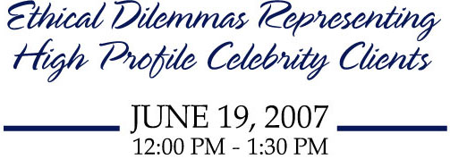
Cosponsored by MusiCares Foundation, Entertainment Law Committee
of the John M. Langston Bar Association, and Dreier Stein & Kahan LLP
This program will educate the attendees about the ethical challenges attorneys face when representing high profile entertainment clients and what alternatives exist to prevent problems from occuring and to address problems when they arise. The panel will focus on such topics as celebrity clients with substance abuse problems, confidentiality issues, media spotlight, gag orders, celebrity entourages, and handling criminal issues.
The ABA will apply for ethics and substance abuse MCLE credits from each
state with mandatory CLE requirements. It is anticipated that 1.5 credit hours will be earned.
LOCATION:
The Recording Academy
3402 Pico Blvd. • Santa Monica, CA
Free parking is available. Please enter through The Recording Academy's gate. Additional parking is available at the back.
MODERATOR:
Gary A. Watson, Entertainment Transactional Attorney
Gary A. Watson & Associates, PC • Los Angeles, CA
SPEAKERS:
Dr. Sheila Balkan, Criminologist
Los Angeles, CA
Stephen D. Barnes, Entertainment Transactional Attorney
Barnes Morris Klein Mark Yorn Barnes & Levine P.C • Santa Monica, CA
Anthony Brooklier, Criminal Defense Attorney
Marks & Brooklier • Los Angeles, CA
Harold Owens, Senior Director of Addiction Recovery Services
MusiCares Foundation •Santa Monica, CA
Michael J. Plonsker, Entertainment Litigation Attorney
Dreier Stein & Kahan LLP • Santa Monica, CA
COST: Sorry, no discounts or waivers will be accepted.
Forum on the Entertainment and Sports Industries Members: FREE
Forum Law Student Members: FREE
Non-Forum ABA Members/Non-Forum Law Students: $10.00
General Public : $25.00

REGISTRATION:
SPACE IS LIMITED TO 75 ATTENDEES • Box lunches will be provided.
ADVANCE REGISTRATION DEADLINE : June 11, 2007
To Register Online: Visit us at www.abanet.org/forums/entsports.
To Pay by Check: Mail form below along with a check, payable to the ABA,
to: ABA Forum on the Entertainment and Sports Industries
321 N. Clark Street • Chicago, IL 60610
To Pay by Credit Card: Fax the form below to: 312/988-5677.

